SEC Form 3
FORM 3 | UNITED STATES SECURITIES AND EXCHANGE COMMISSION  Washington, D.C. 20549  INITIAL STATEMENT OF BENEFICIAL OWNERSHIP OF SECURITIES  Filed pursuant to Section 16(a) of the Securities Exchange Act of 1934  or Section 30(h) of the Investment Company Act of 1940
  OMB APPROVAL
  OMB Number: | 3235-0104
  Estimated average burden
  hours per response: | 0.5
1. Name and Address of Reporting Person*  (Street) | 2. Date of Event Requiring Statement (Month/Day/Year)  09/25/2026 | 3. Issuer Name and Ticker or Trading Symbol  Asana, Inc. [ ASAN ]  Foreign Trading Symbol
  Le Heather Tram
  (Last) | (First) | (Middle)
  C/O ASANA, INC.
  633 FOLSOM ST. SUITE 100
  SAN FRANCISCO | CA | 94107
  (City) | (State) | (Zip)
 |  | 4. Relationship of Reporting Person(s) to Issuer  (Check all applicable) | 5. If Amendment, Date of Original Filed (Month/Day/Year)
   | Director |  | 10% Owner
   | Officer (give title below) |  | Other (specify below)
  Chief Accounting Officer
6. Individual or Joint/Group Filing (Check Applicable Line)
Form filed by One Reporting Person
Form filed by More than One Reporting Person

Table I - Non-Derivative Securities Beneficially Owned
1. Title of Security (Instr. 4) | 2. Amount of Securities Beneficially Owned (Instr. 4) | 3. Ownership Form: Direct (D) or Indirect (I) (Instr. 5) | 4. Nature of Indirect Beneficial Ownership (Instr. 5)
Table II - Derivative Securities Beneficially Owned
(e.g., puts, calls, warrants, options, convertible securities)
1. Title of Derivative Security (Instr. 4) | 2. Date Exercisable and Expiration Date (Month/Day/Year) |  | 3. Title and Amount of Securities Underlying Derivative Security (Instr. 4) |  | 4. Conversion or Exercise Price of Derivative Security | 5. Ownership Form: Direct (D) or Indirect (I) (Instr. 5) | 6. Nature of Indirect Beneficial Ownership (Instr. 5)
1. Title of Derivative Security (Instr. 4) | Date Exercisable | Expiration Date | Title | Amount or Number of Shares | 4. Conversion or Exercise Price of Derivative Security | 5. Ownership Form: Direct (D) or Indirect (I) (Instr. 5) | 6. Nature of Indirect Beneficial Ownership (Instr. 5)
Explanation of Responses:
Remarks:
Exhibit 24 - Power of Attorney
No securities are beneficially owned.
 | /s/ Katie Colendich, Attorney-in-Fact | 09/28/2026
 | ** Signature of Reporting Person | Date
Reminder: Report on a separate line for each class of securities beneficially owned directly or indirectly.
* If the form is filed by more than one reporting person, see Instruction 5 (b)(v).
** Intentional misstatements or omissions of facts constitute Federal Criminal Violations See 18 U.S.C. 1001 and 15 U.S.C. 78ff(a).
Note: File three copies of this Form, one of which must be manually signed. If space is insufficient, see Instruction 6 for procedure.
Persons who respond to the collection of information contained in this form are not required to respond unless the form displays a currently valid OMB Number.
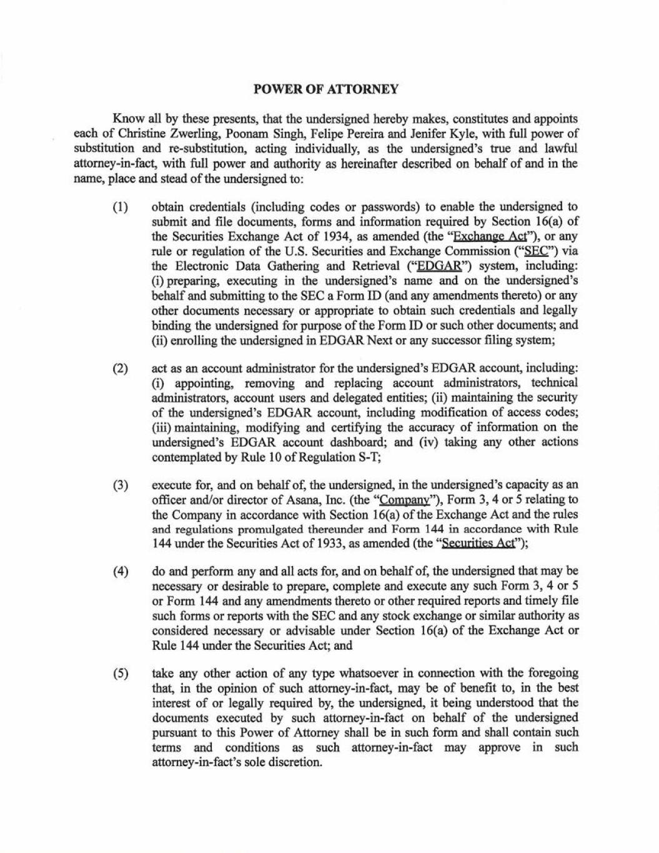

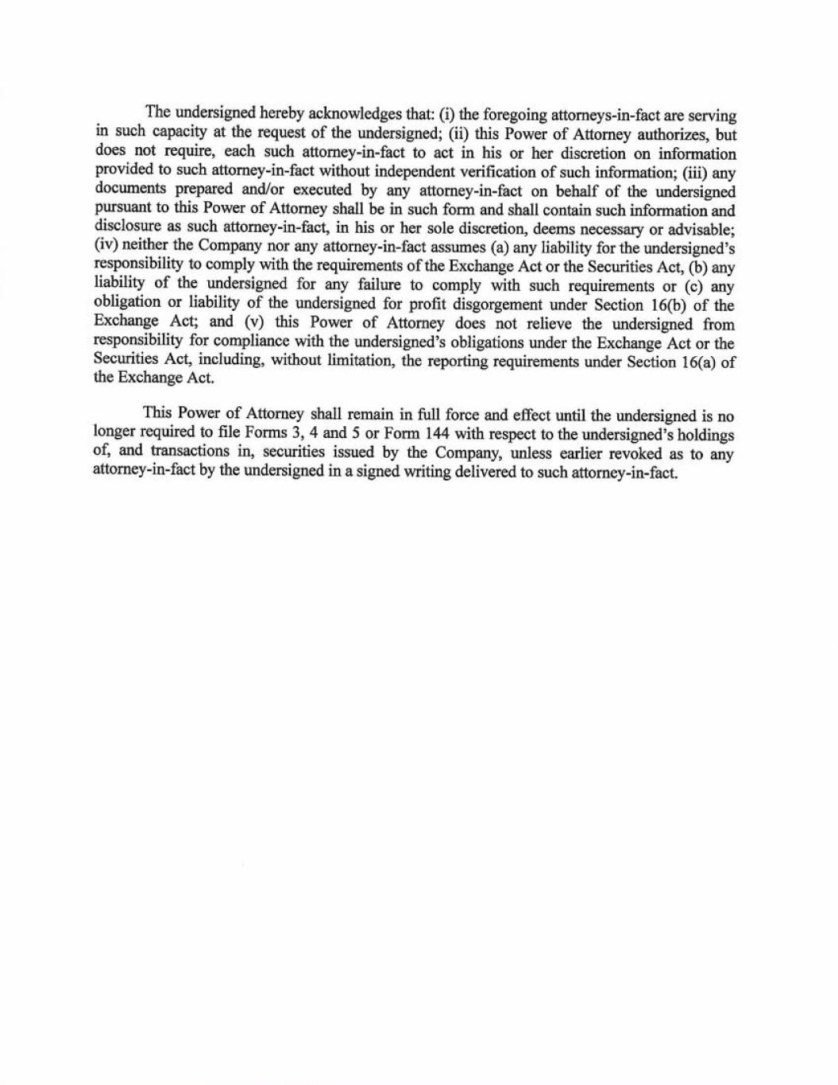

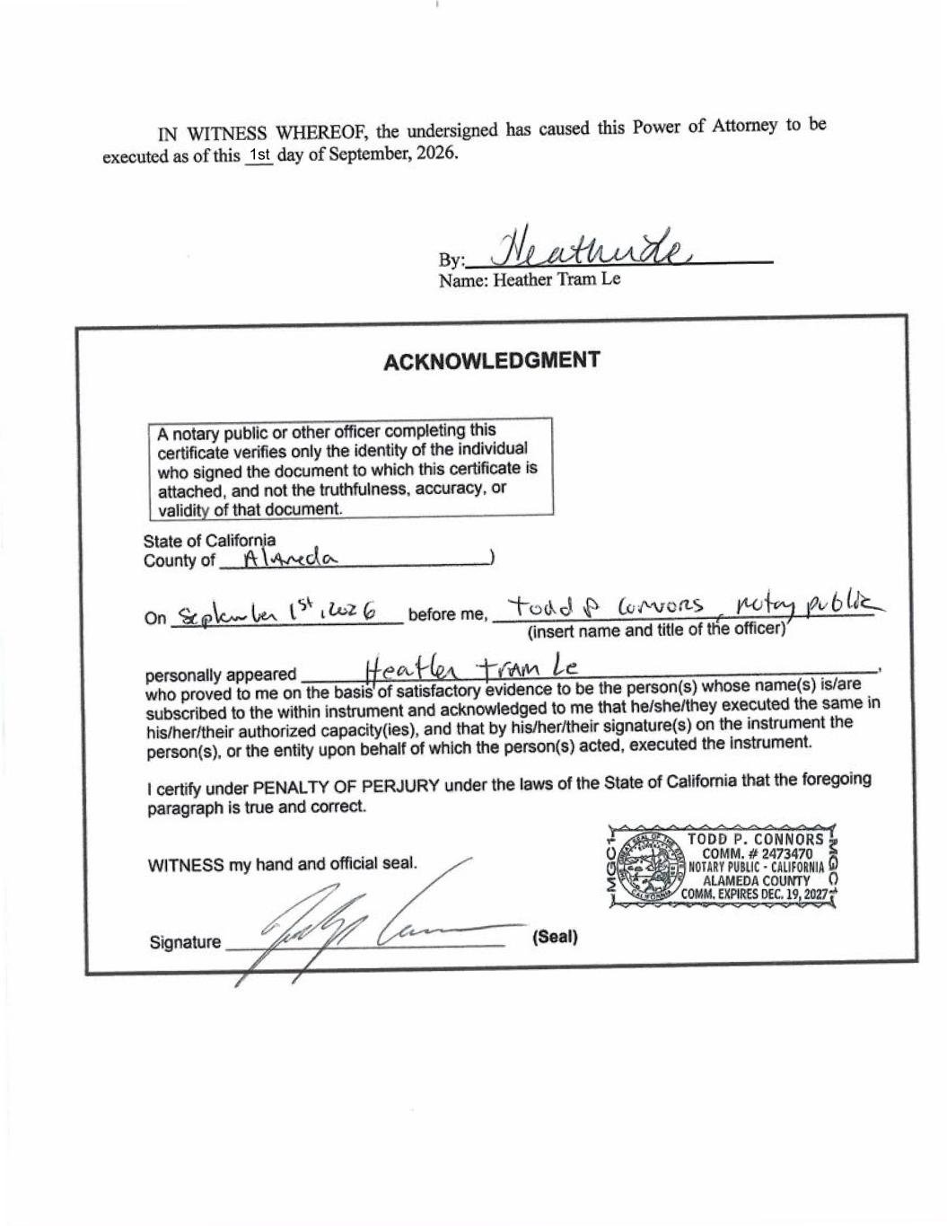
1st

